To Whom it May Concern,

I object to the proposed housing development on the land West of Hither Green Lane for a variety of reasons, I highlight below some of these concerns for your consideration in this process.

**Flooding**

Food risk in the area is high due to being near the River Arrow. Loss of natural drainage increases frequency of flooding and climate change will bring increased rainfall intensity, this leaves the areas surrounding River Arrow increasingly at risk of adverse flood effects.

With a property located within 200m of a high risk flood area, this does raise significant concern for me.  I ask the council planning team to consider the implications for River Arrow flooding on the existing developments and further downstream and not just the risk of flooding for the new development.

Please consider the proposed housing development in the context of its surrounding area and the ongoing changes within it, rather than in isolation of this parcel of land.    Over the past few years there has been substantial development on the green land opposite Abbey Stadium and there is approval for further development there.  This, coupled with development on the land proposed by David Williams Homes would result in losing a substantial amount of natural land drainage near the River. With more solid landscaping, roads and housing we will be increasing the volume of surface water run off to the River Arrow.

Please preserve our natural flood defences.

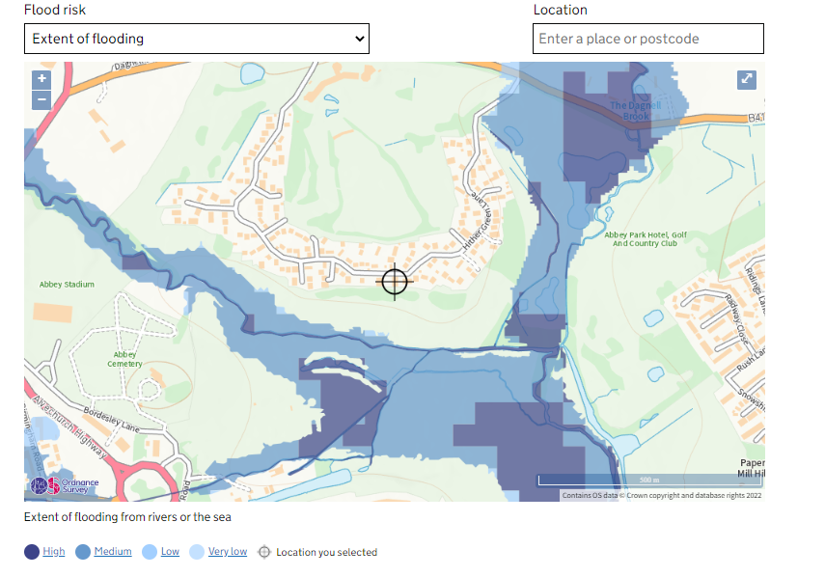

Source:

https://check-long-term-flood-risk.service.gov.uk/map?easting=404867&northing=269022

**Access**

The access design is poor, with only one entry and exit point thus creating an Island Development.    There is inadequate walking, cycling and public transport connections and thus residents on this new development would be reliant on private vehicles for all their journeys. I see David Williams Homes claims good access to bus and rail routes, however this is not the case.

Firstly, to reach any public transport it would require these residents walk along a non-pedestrianised route along Dagnall End Lane to reach the Birmingham Road. This is a busy junction with a high volume of fast moving vehicles and no street lighting, very dangerous.

Even if some of this danger was overcome with proposed sidewalk the transport links remain inadequate. This can be evidenced by using the Traveline journey planner (which Worchester council link via their webpage). If planning to leave the house at 7.30am to get to the centre of Redditch (bus or train station) by public transport this two mile journey would take someone over an hour. It would require they walk a non-pedestrianised route to Birmingham road, to take a bus to Barnt Green, where they could then walk to Barnt Green Train Station to catch a train to Redditch. Alternatively, they could wait until 9.50am for the first 182 service of the day. For most working individuals neither of these would be a realistic options.

I therefore feel safe in making an assumption that 100% of journeys from this new development would need to be by car, going against government and council aims of reducing reliance on personal vehicles to reduce CO2 emissions.

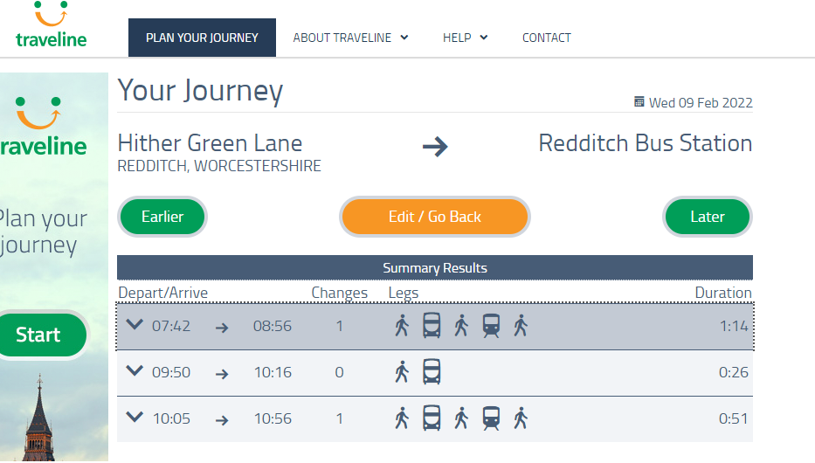

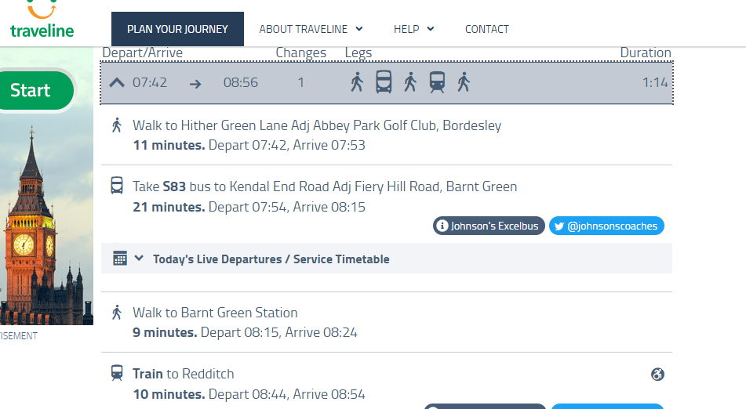

Source:

<https://www.traveline.info/> linked via https://www.worcestershire.gov.uk/info/20021/bus_travel/1001/bus_timetables

**Increased vehicle Traffic**

Island developments are well known to force residents into vehicles to make their journeys, this coupled with the poor connections to public transport from Hither Green Lane means we should expect at least an additional 1000 car trips per day onto the Hither Green Lane to Dagnall end Junction. This would be a threefold increase of the current 300-400 journeys.  This creates several negative knock on effects I’ll call out my concerns on pollution and congestion.

I raise concerns on pollution for both noise and air quality. Tripling the number of car journeys onto Hither Green Lane is a significant increase to the exiting volume of road traffic noise and therefore I am concerned about this substantial increase in road traffic noise pollution. With more traffic comes more particle and air pollution, as seen below this area already has poorer air quality than Redditch.   Given Redditch has declared climate emergency adding more car journeys to areas with poorer air quality seems counterintuitive to the council aims, especially when we consider that this would be as a result of building on Green Space!

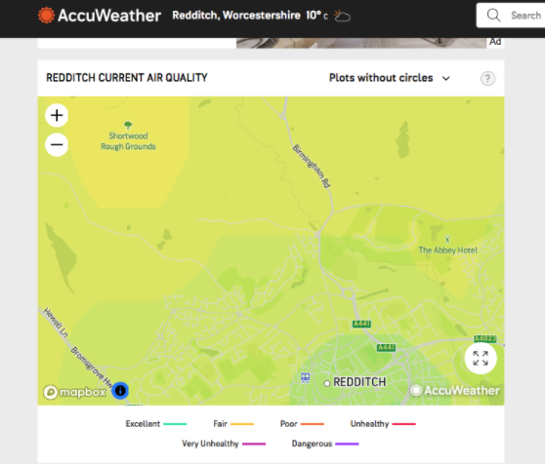

Congestion

Peak periods would see a build-up of congestion for those leaving and entering Hither Green Lane, particularly as hundreds of households look to achieve similar goals at the same time, such as school drop offs and leaving for work. This should be of note as Hither Green Lane exits onto Dagnall End Road which is a busy road, this could become a pinch point. Hither Green Lane currently consists of 172 houses, David William Homes application for 216 additional homes is asking the road to adopt more than twice as much vehicular traffic than it was initially designed for. Even if additional access points onto Dagnall End Lane where to be considered, there would continue to be a challenge with the Birmingham Road / Dagnall End Junction. This is already an overburdened junction, and increasing the number of car journeys by at least 1000 a day will place extra pressure on this junction. We must also bear in mind that there are already substantial housing developments underway in close proximity which will already add to the junction pressure in the future.

**Schools**

I note that David Williams Homes are proposing to build a play area, while this is a wonderful idea it indicates that this is going to provide family housing. This will bring more demand for school places, with local schools are already oversubscribed. As a parent of two preschool children this is an area of great concern for me, particularly with the additional new housing already being built opposite Abby Stadium. More dwellings will further increase this strain. Furthermore with no schools in walking distance we are reliant on a school bus service. There are also safety considerations here, as currently there is no layby for school buses to park on Dagnell End Road, nor is there any provision for school children to safely cross this busy road.

**Covenant**

I understand that this area was originally intended for leisure use for the town of Redditch, and that a covenant was put in place to outline this limitation on the use of land. I ask the council to consider what message is sent when covenants of this ilk are broken without a very strong reason or benefit to the community in which it was originally intended to serve.

My sincere thanks for taking the time to read this summary of my objection. I reserve the right to make further objections to this proposed development if I discover more issues in the future.