113 Hither Green Lane
Redditch
B98 9BN

Dear Mr Lester

21/01830/ful

I wish to object to the proposed housing development on Abbey Park Golf Course on the following grounds:

- Loss of green space and impact on leisure:

The area for the proposed development is currently a ‘designated open green space’ and is not currently earmarked as a strategic site for housing development. People daily use the area to walk, run and dog-walk in a safe open space away from traffic.

From its inception as a New Town, open space has been a defining characteristic of Redditch, and over the years the Council has reiterated the importance of this principle:

"The landscape framework in which the town is held is a particularly successful element of the total environment and was under the aegis of Corporation Landscape Architect from 1967 to 1984. The framework arose from the factors of topography, climate, watersheds and indigenous vegetation all of which were thoroughly analysed and incorporated into the Master plan.”

and

"Proposals which would lead to the total or partial loss of Primary Open Space will not normally be granted planning permission unless it can be demonstrated that the need for development outweighs the value of the land as an open area” https://redditchbc.gov.uk/media730924/open-space-standards.pdf
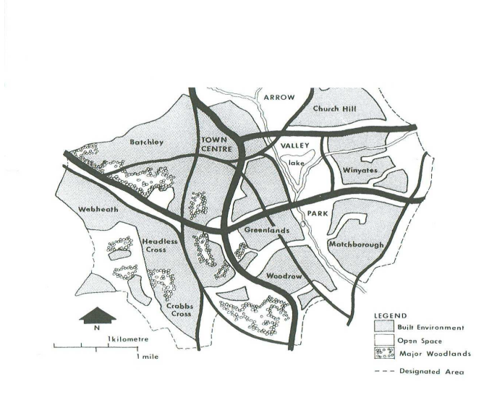
The proposed development contravenes these laudable principles as sufficient land has already been identified to meet Redditch’s housing needs up to 2030. Indeed, the developments at Millwood Meadows and continuing development in that area have already resulted in a substantial loss of original green belt land and changed the character of the approach to Redditch from the north.

- Environmental and Climate Impact

Although the proposed area of development itself is flood level 1, it should be noted that river Arrow abuts this, and areas of the Abbey Park golf course are in flood zones 2 and 3 and regularly flood, indeed there has been flooding nearly up to the boundary of our property. The development of a housing estate of 216 properties will inevitably lead to a loss of natural land drainage therefore increasing the flood risk. Studying the flood zone map (https://check-long-term-flood-risk.service.gov.uk/) shows that the likelihood is that existing properties will be badly affected, especially when one considers the water from Dagnell Brook (which already floods) joining with the Arrow.

There is rightly great concern worldwide about the effects of climate change, the National Trust commissioned a report which stated:

“Greening neighbourhoods, towns and cities brings a host of wider benefits to people’s lives, improving air quality, reducing summer temperatures and surface flooding, and making cycling and walking even more attractive.
It will also help make cities and towns resilient to climate change and achieve net zero ambitions, with this scale of investment delivering one in 12 of the UK’s tree planting target.” https://www.nationaltrust.org.uk/press-release/new-research-shows-55bn-fund-needed-to-level-up-access-to-urban-green-space-as-part-of-uks-green-recovery
The Environment Agency submitted a report (Living Better with a Changing Climate) in October 2021 warning that:

“… the UK is dangerously underprepared for the physical impacts of climate change that are already baked in, regardless of future emissions reductions on the road to net-zero by 2050.
An increase in winter rainfall of 6%, and decrease in summer rainfall by 15%, by the 2050s, is predicted.” 'Adapt or die': Environment Agency slams UK Government's lack of focus on climate resilience (edie.net)
Taking this research into account when looking at the flood zone map (see above for web link) it would seem that the flood zones, already so close our home in Hither Green Lane, will change, putting it at greater risk of flooding.

- Traffic and Transport Impact

A major objection to this planning application is the impact on traffic at the junction of the A441 (Birmingham Road) and Dagnell End Lane, bearing in mind the already long queues at peak times and additional problems caused following rain with flooding on Dagnell End Lane at the junction meaning that the left-turn filter lane can be impassable. On numerous occasions traffic heading from the North into Redditch along the A441 has been queued back to, and even beyond the roundabout at the end of the Alvechurch Bypass.

The Traffic Assessment available on the Planning Portal is concerning: please see below the extracts of particular concern:

        - “Development should only be prevented or refused on highways grounds if there would be an unacceptable impact on highway safety, or the residual cumulative impacts on the road network would be severe.” Application 21/01830/ful Application 21/01830/ful Traffic Assessment

        - “In the absence of being able to conduct traffic surveys as a result of Covid-19 pandemic, traffic flows have been obtained from the TA associated with the Brockhill East site (PJA TA ‘Land at Brockhill East’ Phase 3 June 2019) and from the TA associated with the previous planning application on Hither Green Lane (Travis Baker TA ‘Hither Green Lane, Redditch’; Ref: T16033/TA/01)”. Application 21/01830/ful Application 21/01830/ful Traffic Assessment

        - “It is not therefore considered that the proposed development should be liable for further mitigation, given that the junction is already predicted to operative (sic)beyond its theoretical capacity in the 2030 base. Any further mitigation is unlikely to be achievable under a S278 agreement given widening of Dagnell End Road requires land beyond the extent of the highway boundary”. Application 21/01830/ful Application 21/01830/ful Traffic Assessment

Reading these points together it is clear that:

- No actual traffic flow survey has been conducted for this application (point b above)

- No account has been taken of the traffic using the Abbey Hotel: indeed, the current ‘overflow’ car parking will be lost. There is a gym and swimming pool on site which has members attending throughout the day and evening, the hotel uses its function suite and restaurant for both funeral wakes and weddings, and parking for these often results in people parking along the road. Looking at the function and meeting rooms available there could be in excess of 300 people attending events on any day, and that excludes hotel guests, day golfers, driving range users and Leisure Club members.

It can only be remiss or deliberate therefore that these traffic flows into and out of Hither Green Lane have not been assessed and taken into consideration.

- The traffic flow survey used to extrapolate conclusions refer to the Weights Lane development and the new Weights Lane roundabout. Already at peak times, north-bound traffic can be queued back beyond the Weights Lane roundabout. At times it has even been queued beyond the Sainsburys roundabout and up the hill. (Point b above)

- The Dagnell End/A441 junction without this development will in a few years (if not already) be operating beyond its theoretical capacity. (Point C)

Any person using the Dagnell End/A441 junction, be they residents of Hither Green Lane, Beoley, Church Hill North or from further afield, would be able to tell you that using this junction, even without the additional problem of frequent flooding, can be a nightmare in terms of traffic. Indeed, local schools have had staff arriving late because of the traffic jams approaching from the north along the A441.

Therefore, any additional traffic of the magnitude expected from this development would certainly meet the criteria outline in Point a above, in that residual cumulative effects on the road network would be severe.

In conclusion, I strongly object to this planning application and would welcome the opportunity to meet face to face with you to discuss my concerns.

Yours sincerely

Betty Sadler (Mrs)

